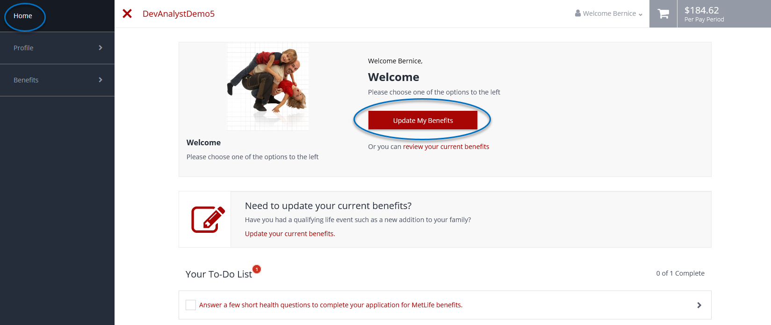

1. Log into PlanSource
2. From the Home page, select **Update My Benefits**.

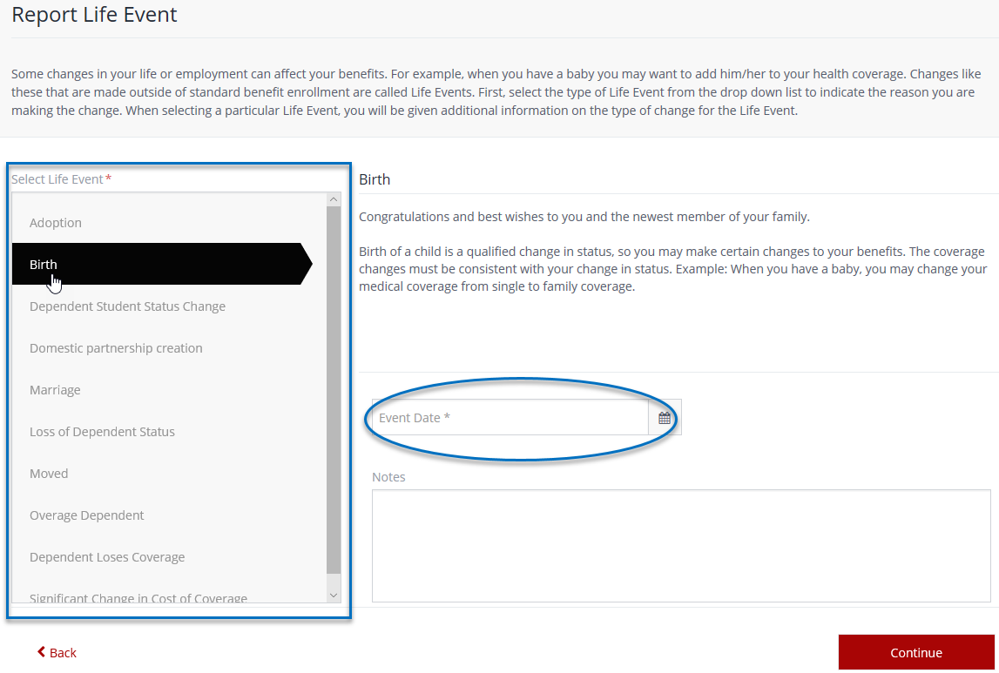

**3.** Select the Life Event that meets your needs and enter the Event Date, then select **Continue**



**5.** When you finish making any necessary updates, select **Review and Checkout**

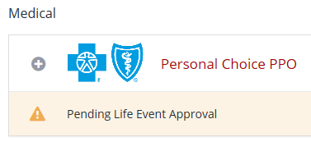

**Please Note:** Your change(s) will not reflect (with carriers and payroll) until your Life Event is approved by your HR Administrator. Once approved, the change(s) will be retroactive to the effective date of the event**.**



**6.** If satisfied with your changes, select **Checkout** to complete your Life Event



**4.** You will then proceed through the enrollment wizard to make your intended changes