**4.**

Make Updates to current Beneficiary or Add Beneficiary

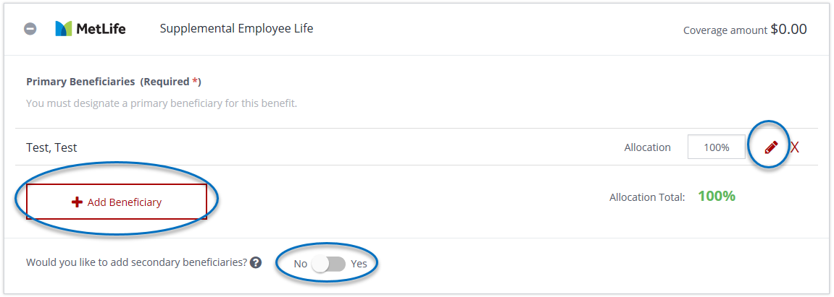

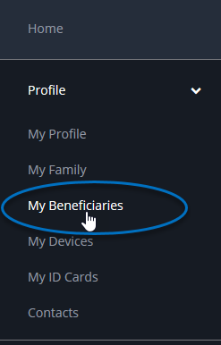

1. Log into PlanSource
2. Select **My Beneficiaries** from the left-hand menu
3. Select the applicable plan year for which you wish to update beneficiaries

