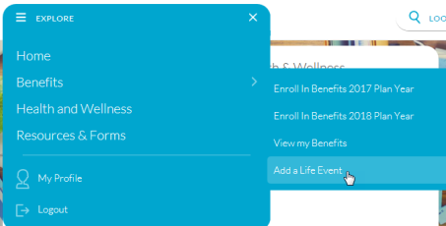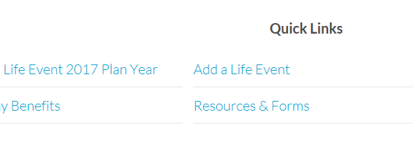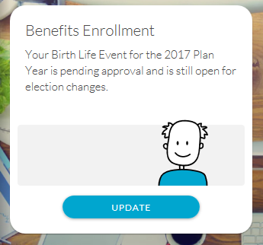

When a life event is pending, employees see a plan card as below. To initiate, they can select the **Add a Life Event** link from the **Quick Links** section on the bottom, or click the **Explore** drop-down on top of the page and select from there.

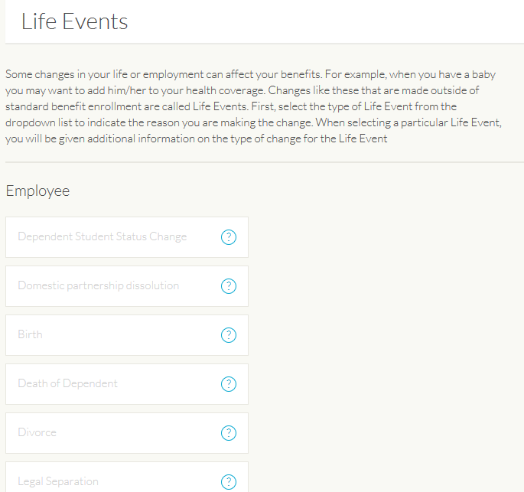

When they choose to add a life event, employees are directed to this page to select the type of life event that applies to them.

Based on the type of life event, employees are asked to update their Marketlink profile.

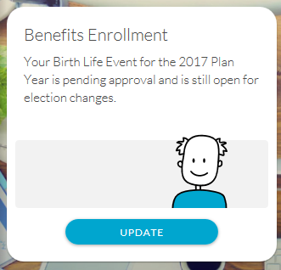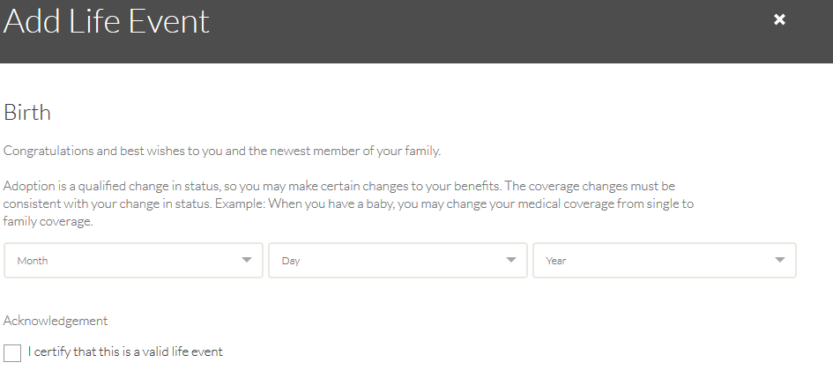

From here, it prompts the user to update their enrollment.

**Note**: Employees are only able to update their enrollment elections based on the IRS guidelines provided on the CIW.

After the employee makes their enrollment changes, a request is sent for approval on the HR admin platform under **Things That Need Your Attention**.

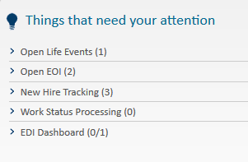

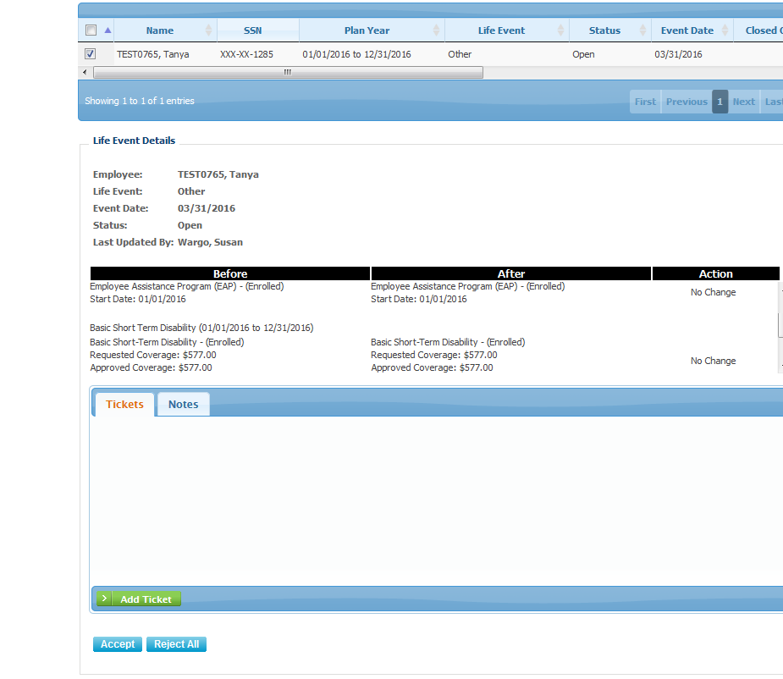

Select the life event on top of the page; select any approvals on changes to the right of each change, then **Accept** or **Reject All** on the bottom of the screen.