Entering a Qualifying Life Event in MarketLink is quick and easy, and can be done at any time throughout the year, outside of Open Enrollment. Follow the steps below to complete.

From either the Explore menu or the Quick Links section, click to Add a Life Event.
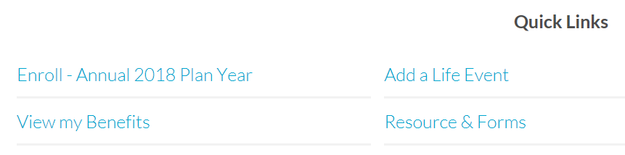

The screen starts with some of the more frequently used event types, but scrolling down reveals a list of all possible events. Select the one you need, and move to the next screen.
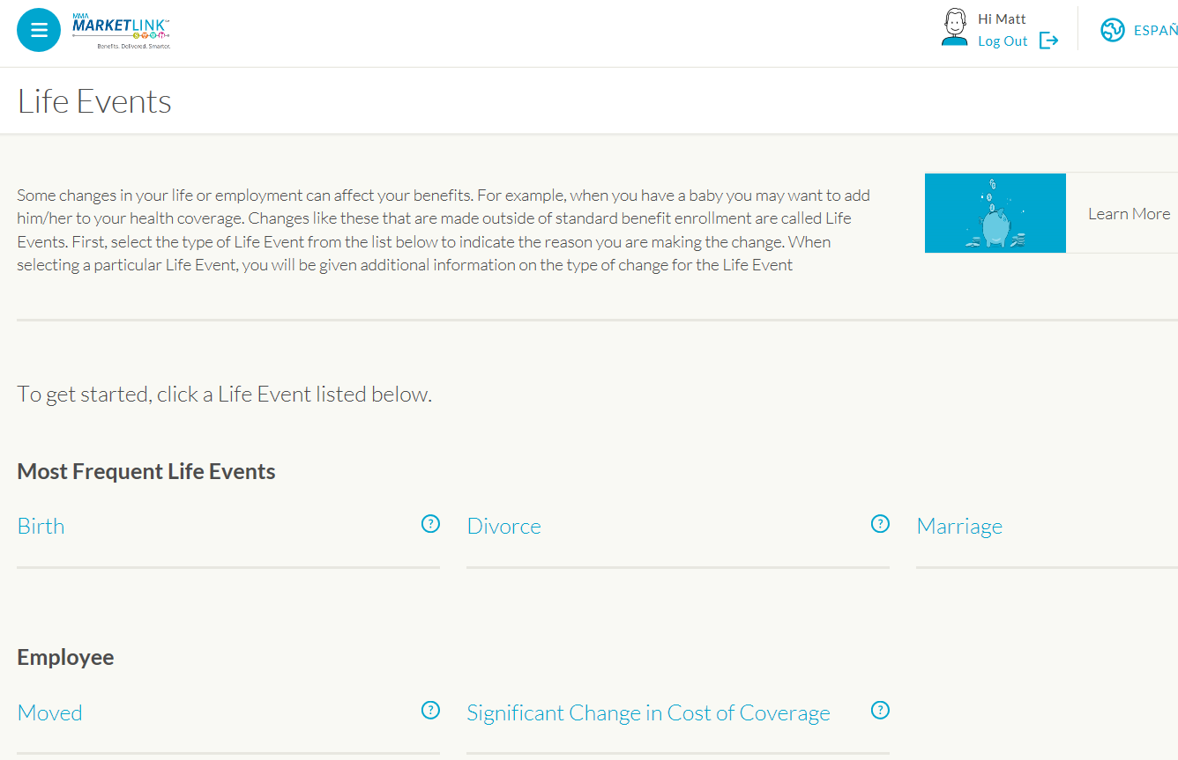
The last screen asks for a few details (this will differ depending on the event). Complete the required fields and click Save.
