# 

# Self-Service Enrollment Guide (Detailed)

March 2018



### Table of Contents

[Self-Service Enrollment Guide (Detailed) 1](#_Toc508342652)

[Table of Contents 3](#_Toc508342653)

[Legal Notice 3](#_Toc508342654)

[Self‐Guided Enrollment Tour 4](#_Toc508342655)

[Enrolling in Benefits 4](#_Toc508342656)

[Logging On 4](#_Toc508342657)

[Multi-Factor Authentication 5](#_Toc508342658)

[Welcome Screen 7](#_Toc508342660)

[Quick Links.............................................................................................................................](#_Quick_Links)8

[Beginning the Enrollment 10](#_Toc508342662)

[Enrollment Navigation 11](#_Toc508342663)

[Review Profile 13](#_Toc508342664)

[About Your Dependents 14](#_Toc508342665)

[Time to Enroll! 16](#_Toc508342666)

[Electing Your Benefits 16](#_Toc508342667)

[Spending Account Options And Elections 22](#_Toc508342669)

[Summary: A Full View of Your Benefits 23](#_Toc508342670)

[Resources & Forms 24](#_Toc508342671)

[Qualifying Life Event Status Change Reasons and Documentation Needed 24](#_Toc508342672)

### Legal Notice

The information contained in this document is proprietary and confidential to Marsh & McLennan Agency, LLC Company. Recipients are not authorized to duplicate, use or disclose all or any portion of such material to any person or entity for any purpose without expressed written permission from a Marsh & McLennan Agency, LLC Company.

# Self‐Guided Enrollment Tour

## Enrolling in Benefits

Before you begin please make sure you have the following items:

* Social Security Number (SSN) for all legal dependents you wish to enroll in any coverage
* Date of Birth (DOB) for all legal dependents you wish to enroll in any coverage
* Beneficiary Information for Life Insurance, which includes your beneficiaries’ name(s), DOB(s) and SSN(s)

### Logging On

Type in mymarketlink.com/client into the address bar of your internet browser

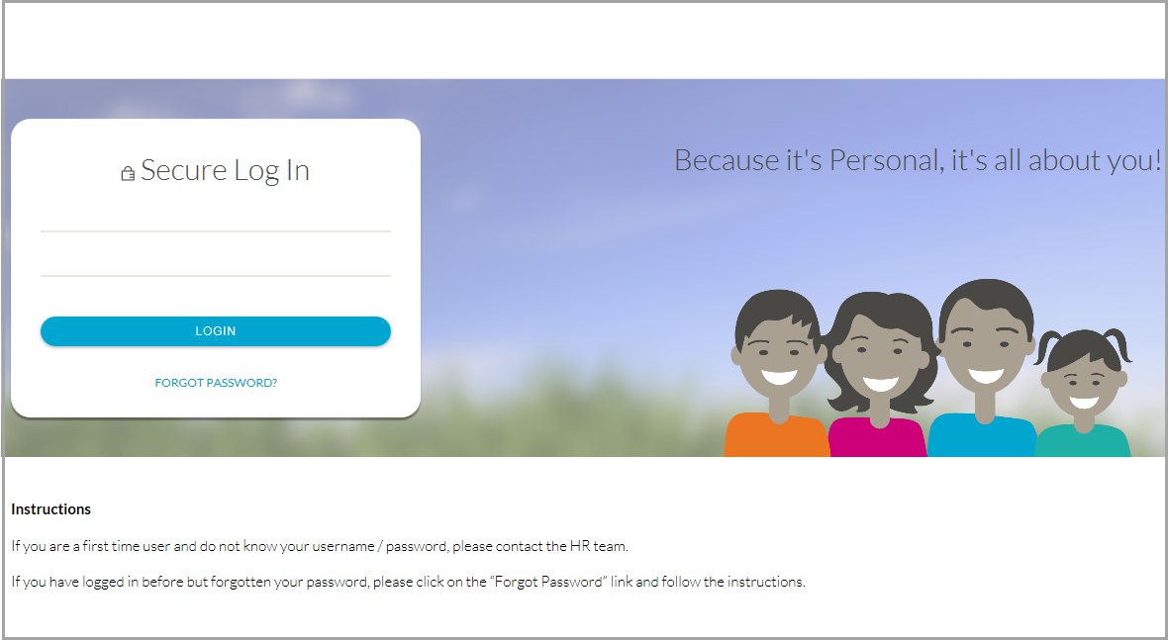

If this is the first time you are using this site follow the instructions below for your user name and Password.

To log on, enter your username (first initial of your first name followed by the first six letters of your last name and last four digits of your Social Security number) and your Password which is your date of birth in the YYYYMMDD format, your first initial (lower case), your last initial (UPPER CASE), plus an exclamation point (!).

**Example:** Rebecca Gray, XXX-XX-2345, August 14, 1962

**Login:** RGray2345, **Password:** 19620814rG!

## Multi-Factor Authentication

After you enter your login credentials, you will be presented with either of the screens displayed below (not both). If you do not have communication methods on file, you’ll see the Self-Registration screen (Left), if you have more than one communication method on file, you’ll have the option to choose your method (Right). After you either enter the information or choose from the methods available, click on Submit to obtain the Verification Code.

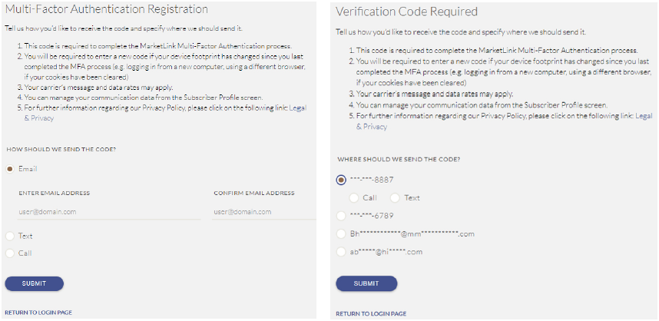

Enter the Verification Code and click on Submit.

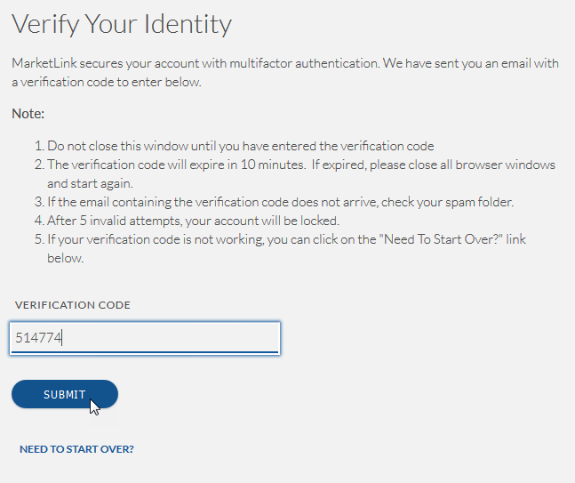

You will then continue through the portal.

**Please Note (Multi-Factor Authentication):** You will only be asked to provide a second layer of authentication once every 400 days, unless, you login from a different browser, device or operating system.

First time users will be prompted to select a new Password, set their Security Questions and update their Profile which includes a choice of avatar. See screen shots below for examples of the screens associates will see as they navigate the system. (**Note**: Every year during Open Enrollment your password will reset back to your date of birth in the YYYYMMDD format, your first initial (lower case), your last initial (UPPER CASE), plus an exclamation point (!))

## C:\Users\lperry\Pictures\Change Password Screen.PNG

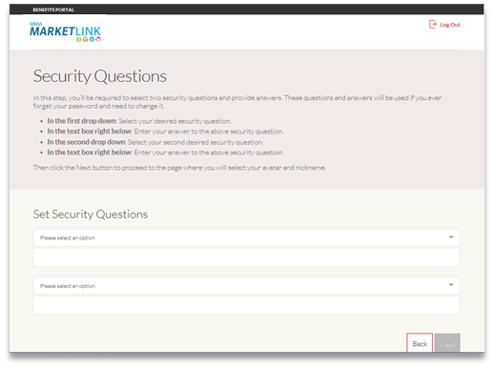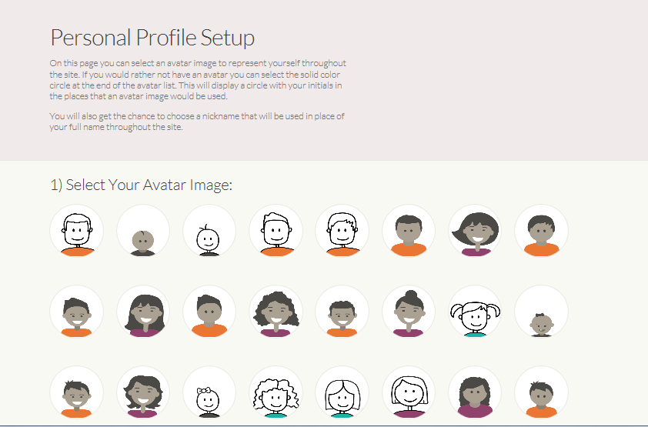

## Welcome Screen

From this screen, you will be able to enroll in or make changes to your benefits, see your benefits summary, and review Benefit Plan Information among other resources. First, we will go through the Enrollment Process; later in this document, we will review steps to update enrollment information. During the annual open enrollment period a reminder will provide you with the number of days you have left to enroll in your benefits in a band at the top of the page.

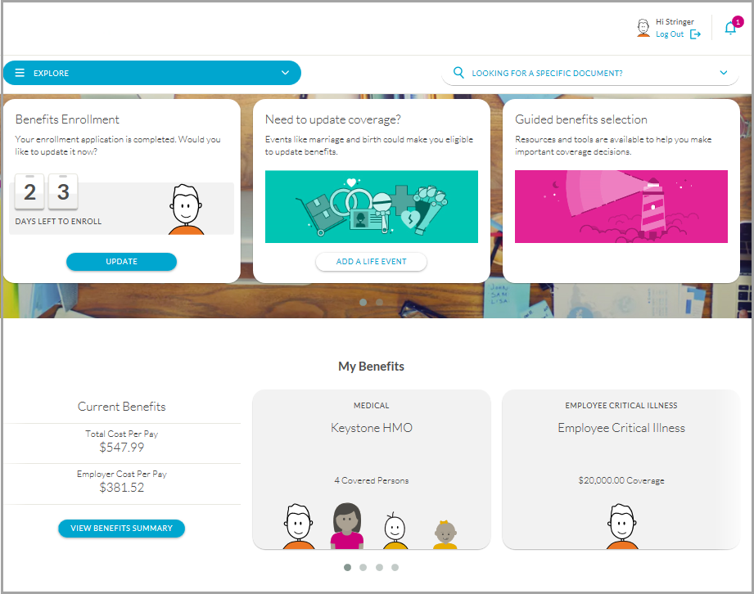

## Quick Links

You can customize Quick Links at the bottom of the home page. This is where you can add links of websites that you want to appear in your Quick Links library.

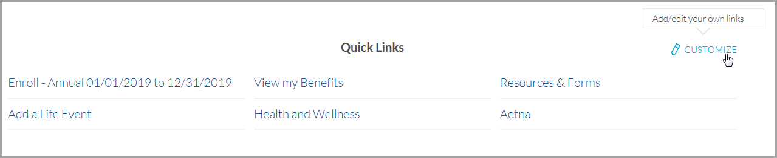

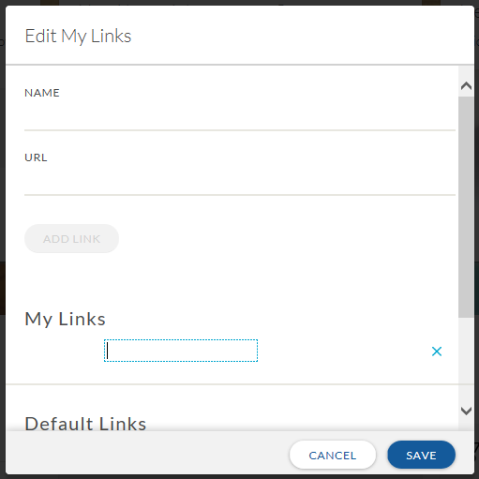

## Introduction

You will be notified of the enrollment due date. You must complete your enrollment by this date. You also have until that date to revisit mymarketlink.com/client to make any changes to your enrollment if necessary.

* Use the EXPLORE menu, the Benefits Enrollment tile or the Quick Links at the bottom of the home page.

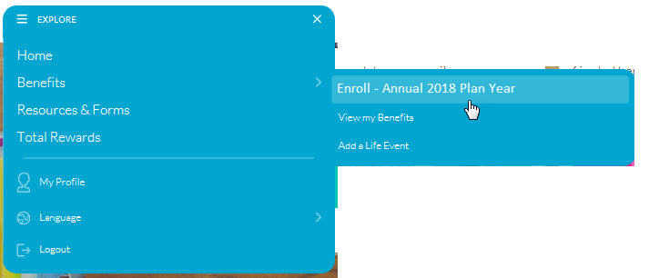

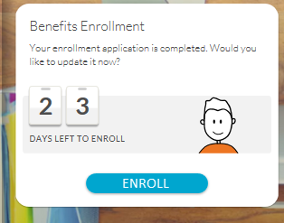

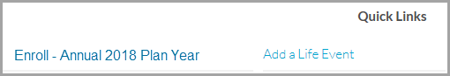

## Beginning the Enrollment

First, you will come to the Welcome page.

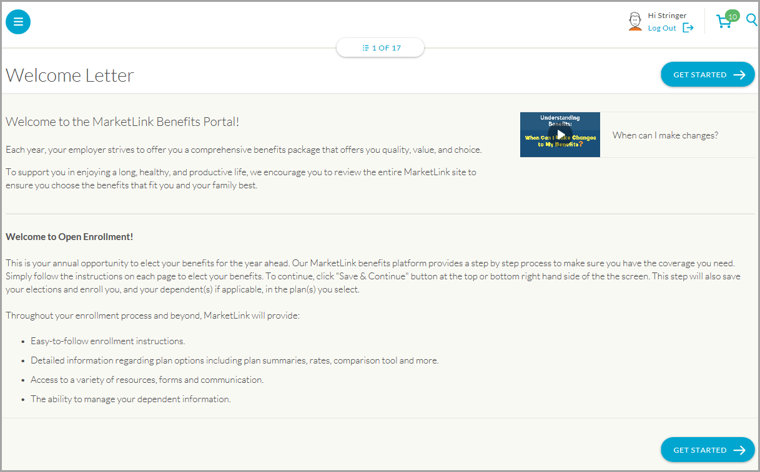

## Enrollment Navigation

Proceed through each enrollment page by using the Save & Continue button.

Use the back button to go back to a previous page – Do not use your browser’s back button.



**Please note**: It is necessary to use the **Save & Continue** button at the bottom or top of every page to access the next enrollment step. **Pressing Save & Continue will also save your selections and enroll you in the plan that you selected**. You can logout and return to finish your enrollment later (within your specified enrollment period).

Some companies will employ the use of certifications to confirm items such as your tobacco-user status. If you see these questions, you will need to respond before moving forward to make benefits elections.

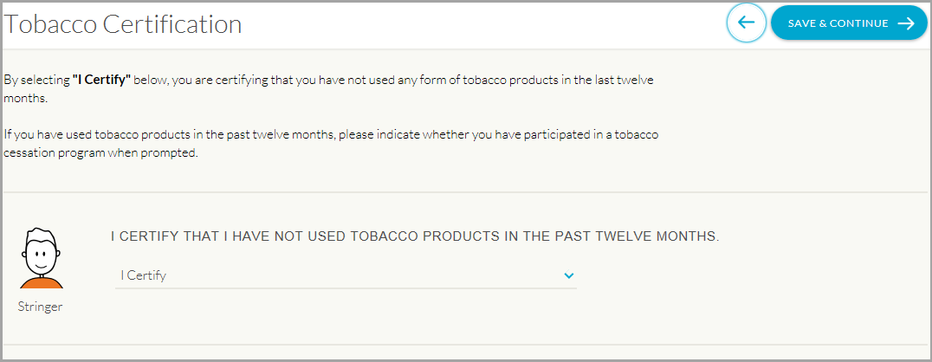

By clicking on the Shopping Cart icon on the top right, you can view your benefit elections and the per pay amounts associated with it. It will also provide you with a combined total. This is accessible at any time, by clicking that same icon on each page.

The pink arrow identify that there is an EOI form associated with that pended election.

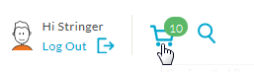

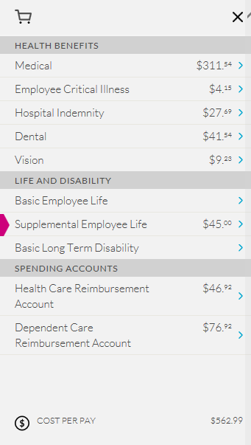

You can click on the count down at the top of the page to go back to any benefit that you’ve already clicked on Save & Continue on.

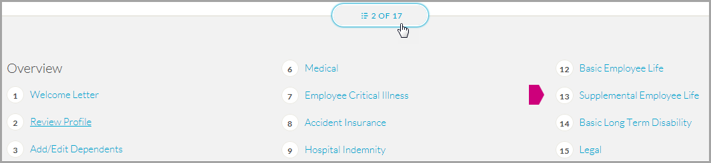

After the Overview page, Employees will be given an opportunity to verify their information, add or edit dependents, and will then proceed through certifications to begin the enrollment process.

### Review Profile

* Read through this page and verify that all information is correct; if there are errors, contact your HR representative for corrections
* Click Save & Continue

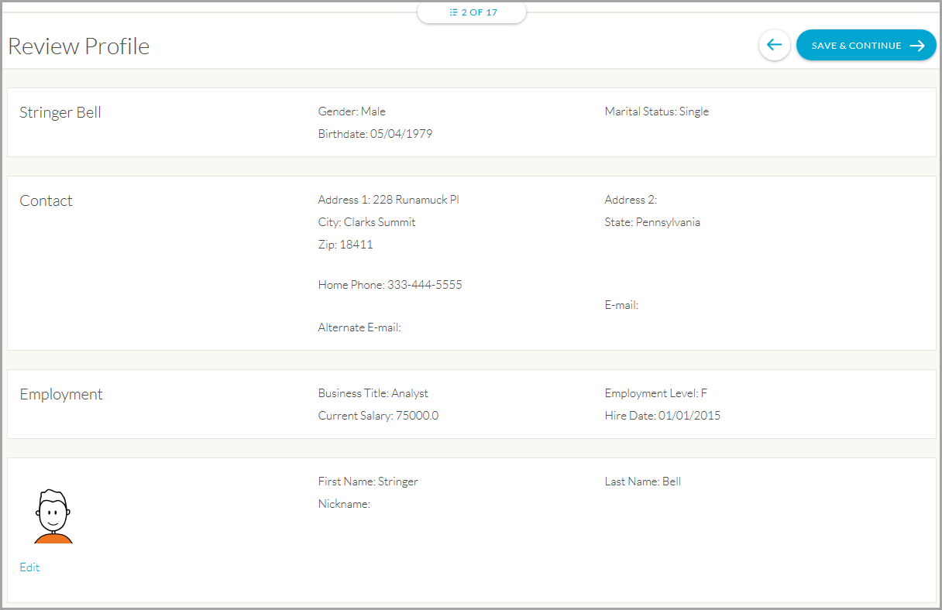

### About Your Dependents

Once you’ve reviewed and updated your profile, you’ll be moved to the Add/Edit Dependents page. Any dependents (i.e. Spouse, Partner, and Child) need to be entered on this page. To enter a new dependent not currently listed on the page:

* Click to Add a dependent and you will be prompted to enter specific information.
* Enter *Dependent Information* (including name, SSN, and DOB), select gender, and avatar.
* Enter the relationship when prompted.
* If the dependent does not live at home, note that as required and add the address
* When you are finished adding all Dependents, Click Save & Continue

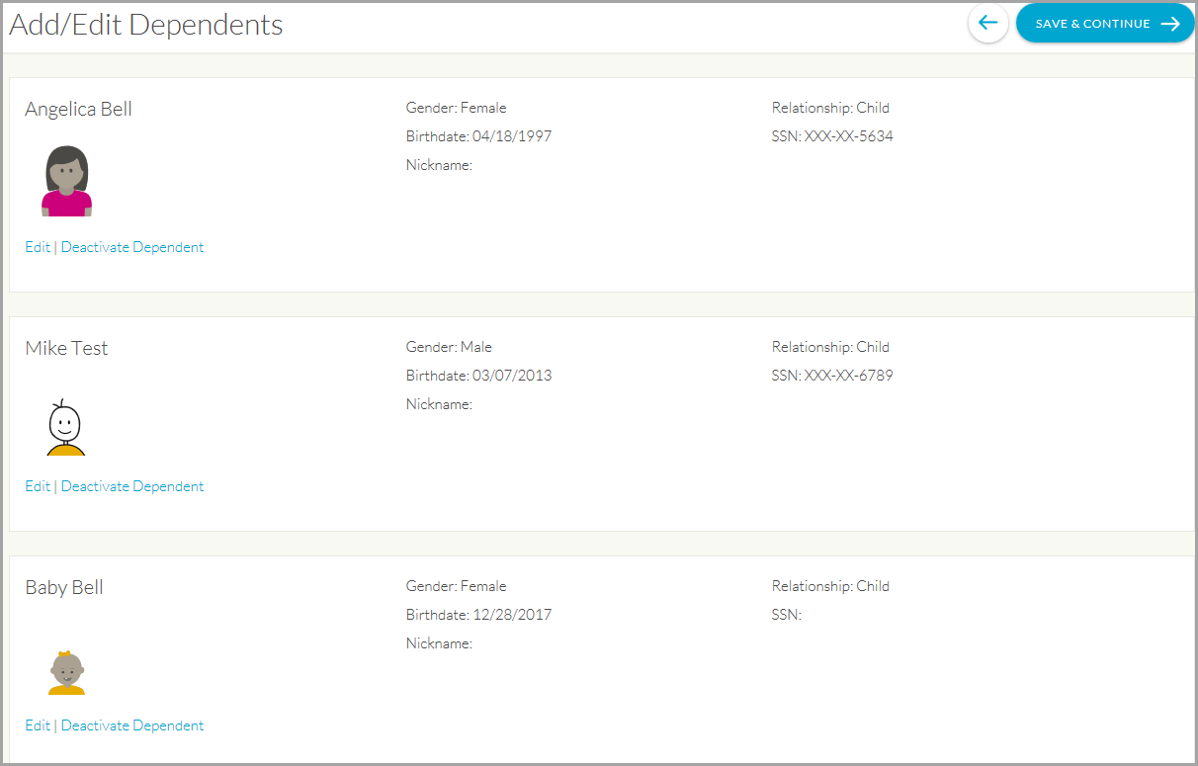

To edit a dependent listed on the page:

* Click Edit.

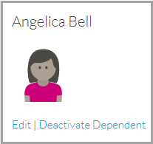

Make the edits to the dependent information, and when finished, click Save & Continue.

To deactivate a dependent listed on the page click Deactivate Dependent.

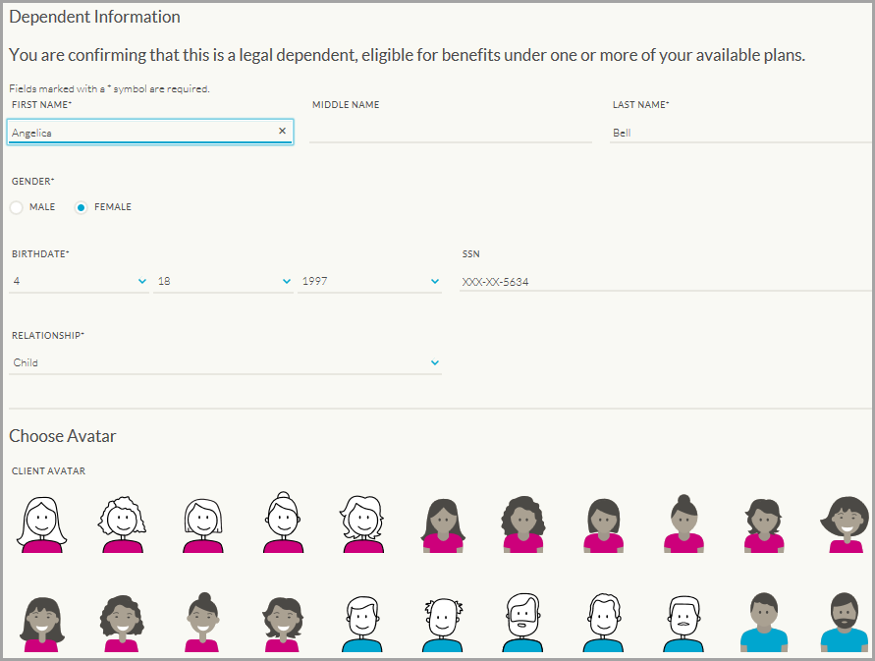

# Time to Enroll!

## Electing Your Benefits

The enrollment wizard will walk you through each benefit choice available. It begins with Medical benefits as shown below.

Some companies will allow you to compare different plan choices by clicking the box labeled Compare.

Once all boxes are checked for plans you wish to compare, click on the Compare Plans.

You can make your selections by clicking on the Choose Plan button at the bottom of each option.

First, the avatars for all benefits eligible persons will appear, and you must choose who will be covered by the plans.

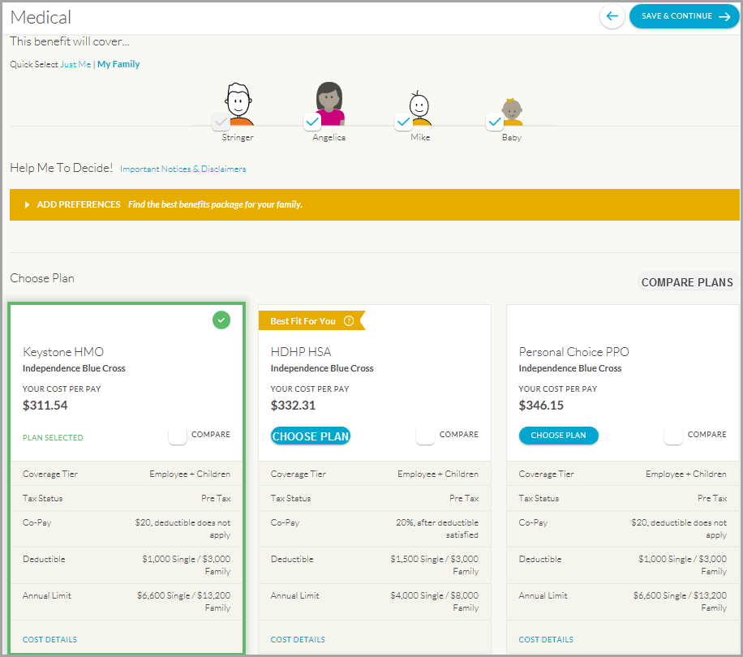

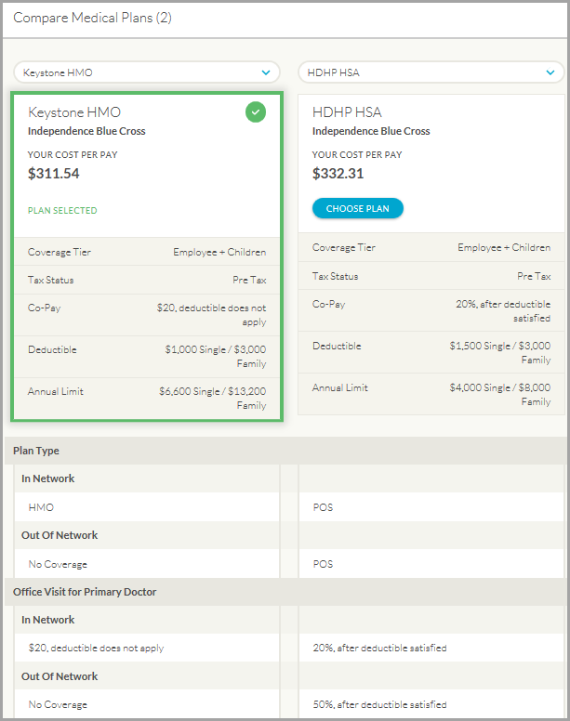

Associates will then proceed through the enrollment wizard and the other benefits available such as:

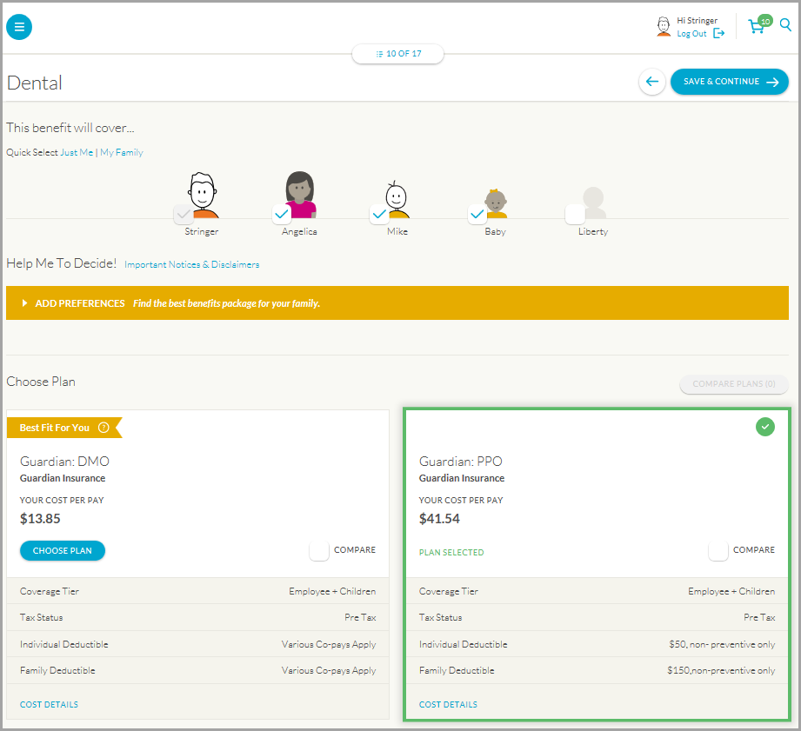

### C:\Users\1021415\AppData\Local\Temp\SNAGHTML8e4c9c.PNGC:\Users\1021415\AppData\Local\Temp\SNAGHTML8f4886.PNGBeneficiary Designation For Basic Life And Voluntary Life Elections

You must elect a **Beneficiary** for any Basic Life/AD&D and Voluntary Life benefits. You can designate as many primary and secondary beneficiaries as you wish; however, the allocation for all of your primary choices must total 100%, and the allocation for all of your secondary choices must total 100%. If you wish to add more than one primary beneficiary, just continue to adduntil all your beneficiaries are noted.

You can also designate one or more secondary beneficiaries. Any secondary beneficiaries will be designated to receive payment in the event the original beneficiary predeceases the insured.

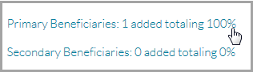

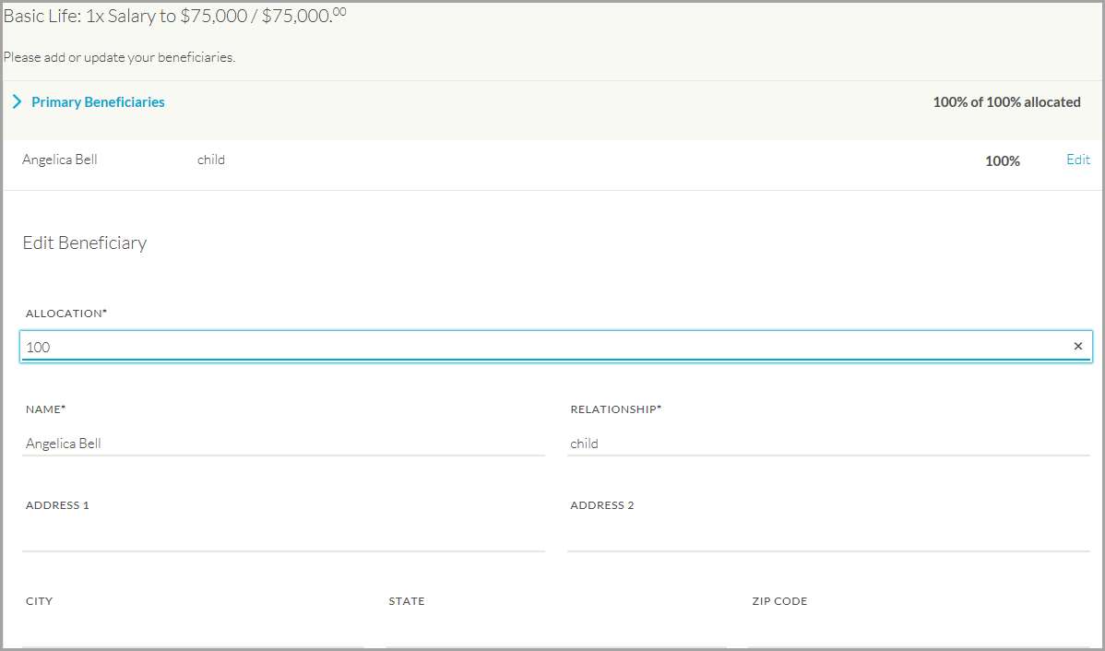

## Spending Account Options And Elections

In this section you will find, and be able to choose any applicable spending accounts your employer offers including: Health Care Spending Account, Dependent Care Spending Account, Health Reimbursement Account, Health Savings Account, Transit/Parking/Commuter.

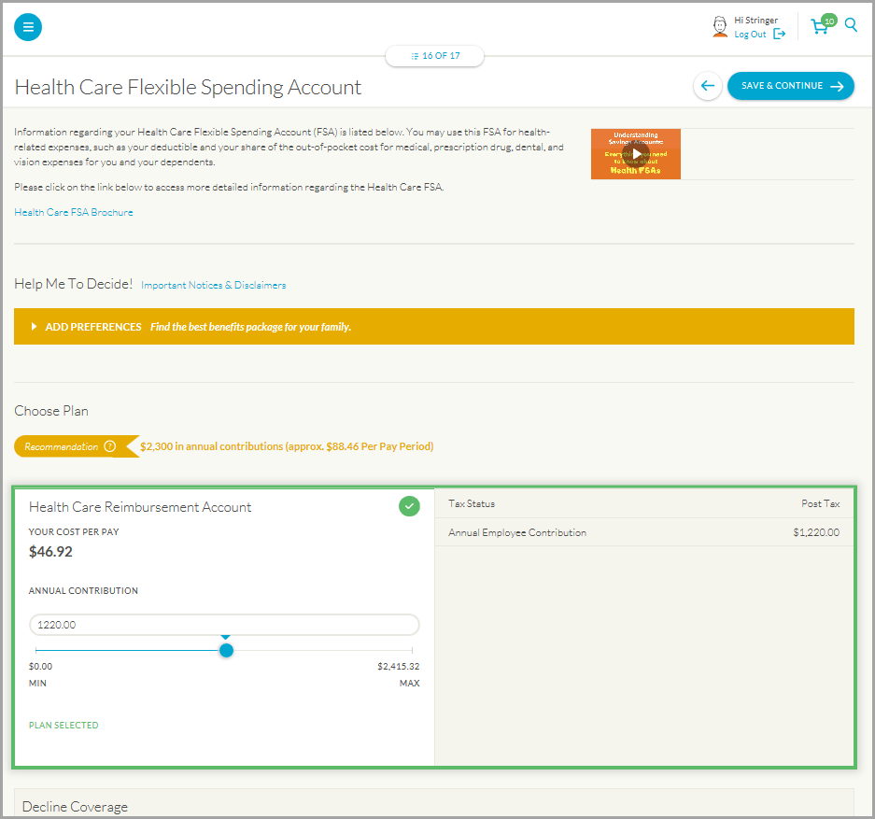

## Summary: A Full View of Your Benefits

From this screen you can print your summary or save it as a .PDF to keep an electronic copy.

## C:\Users\1021415\AppData\Local\Temp\SNAGHTML93fdd1.PNG

## Resources & Forms

Just as on our former enrollment portal, we offer a section dedicated to helpful information in a variety of media to help you understand, choose, and use your benefits wisely.

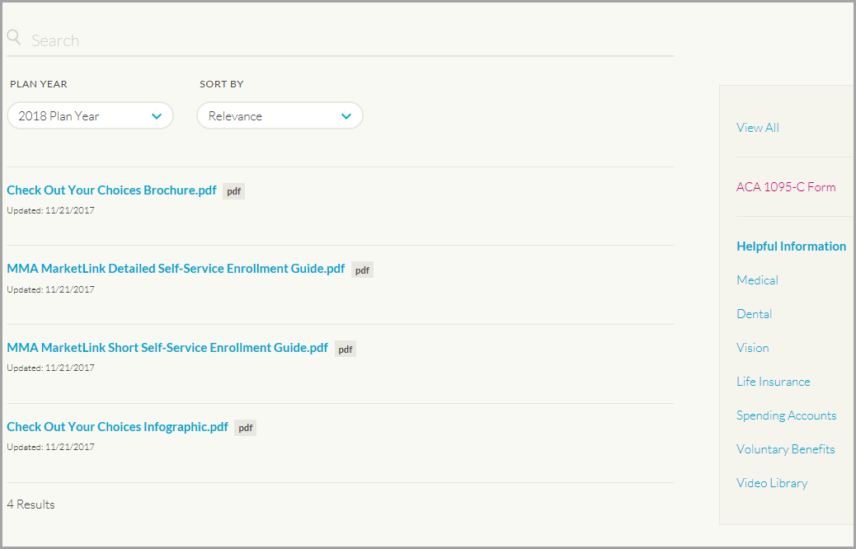

#### It’s important to remember, that this is a year-round portal, which allows you to visit frequently to confirm your benefits elections, make qualified life event changes, and monitor your healthcare spending accounts. If you have questions, please contact [Editor’s note: insert Client Specific Benefits Service Center # and hours here].

# Qualifying Life Event Status Change Reasons and Documentation Needed

If you are making a status change at any time throughout the year you could be required to email, fax, or mail supporting documentation to your HR Department for your status change request to be approved. If your status change requires further documentation, you must send that documentation within 31 days of the event or your request will automatically be denied. Please refer to you HR representative for more information on life change event documentation.

|  |  |
| --- | --- |
| MMA_WSTD_Blue | 2300 Renaissance Boulevard  King of Prussia, PA 19406 |