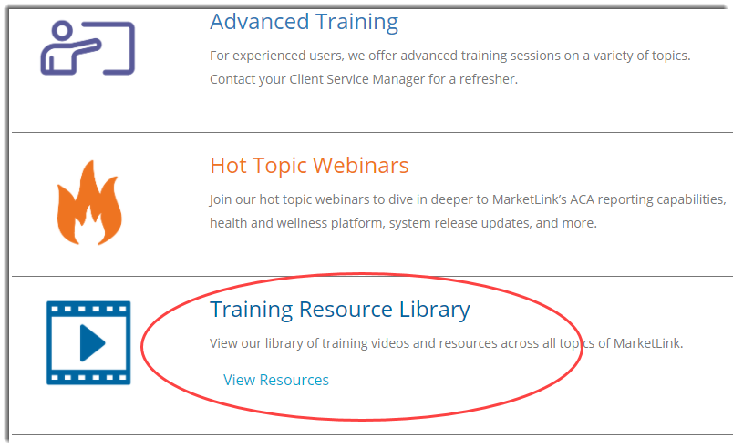

**Go to:** <https://www.trion.com/system-training-resources>

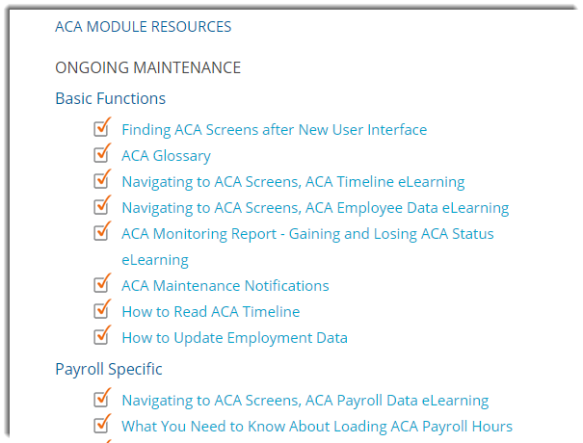

**\* These resources continue to evolve. You may notice additional or updated resources when opening this page.**

**\*3.**

