Once you log into PlanSource, you will land on the Home Dashboard.

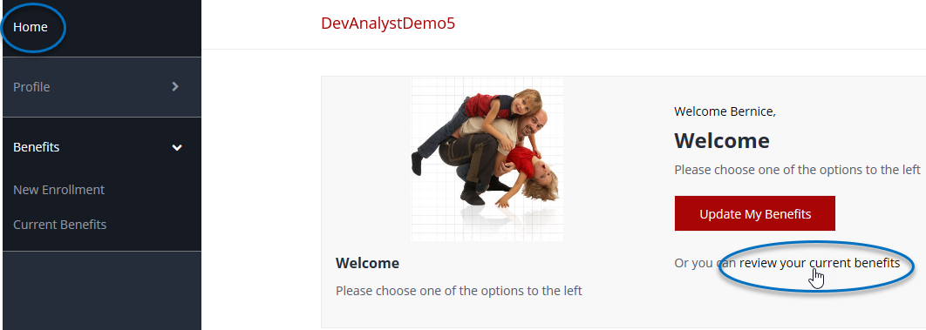

To view your current benefits Confirmation Statement, click on **review your current benefits** on the Home page, or **Current Benefits** from the left side bar.

During an Enrollment Period, once enrollment is complete, it will take you to this page, where you can print out your Confirmation Statement.

Click on the **Print** icon to print your Confirmation Statement.

