Once an HR administrator is notified that a qualified life event (QLE) has been submitted, it’s imperative to take immediate action so that the change(s) are sent to the carrier(s) timely and the QLE is closed.
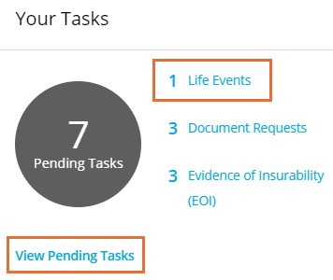

- Log into the portal as an HR Admin
- From the Dashboard, click on Life Events
or View Pending Tasks. You can also
click on Tasks within the Employee section
of the left-hand menu.
- From the Tasks page, click the Life Events
tab to view all open and pending life events.
Then click on the record you wish to view/update.
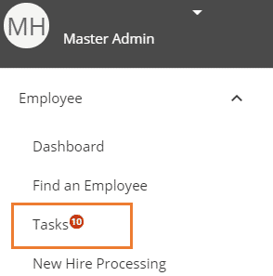

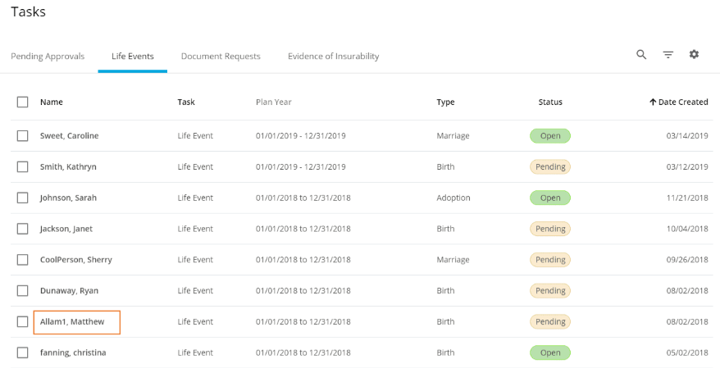

- Scroll down to view the activity details for the QLE, including the before and after changes requested by the employee. You have the ability to Allow or Disallow each action taken. At the bottom, click Accept or Reject to complete the process.

